**Practical No 5 Date:** 31/07/2023

**Title:** Find the largest number among the numbers entered and Factorial of a number using Python.

**Description:**

Python was developed by Guido van Rossum in the late eighties and early nineties at the National Research Institute for Mathematics and Computer Science in the Netherlands. Python is derived from many other languages including ABC, Modula-3, C, C++, Algol-68, SmallTalk, and Unix shell and other scripting languages. Python is copyrighted. Like Perl, Python source code is now available under the GNU General Public License (GPL).

**Syntax for *if-else* statement in Python:**

*if condition :*

*Statements*

*else:*

*Statements*

*if condition :*

*statements*

*elif condition:*

*statements*

*else:*

*statements*

**Syntax for *for* loop in python:**

*for variable in sequence:*

*statements*

**Program Code:**

list1=[]

max=0

number=int(input("Enter number of Elements in the list:"))

for i in range(1,number+1):

  elements=int(input("Enter the elements:"))

  list1.append(elements)

  if(elements>max):

    max=elements

print("Largest element is:",max)

factorial=1

for i in range(1,max+1):

  factorial=factorial*i

print("Factorial of",max,"is",factorial)

**Input and Output**

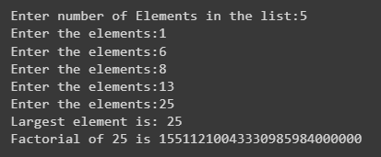

**Conclusion:** Thus we have implemented python program to find largest of three numbers and factorial of number.

**Practice programs:**

1. Write a Python Program to implement a calculator.
2. Write a Python program to find LCM and GCD of two numbers.